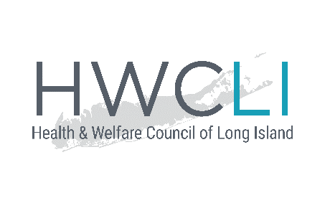
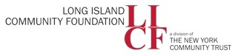
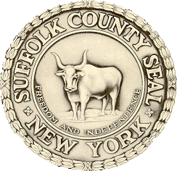

2020 Census Suffolk County Complete Count Committee
February 13, 2019 Meeting
Minutes
Partnership with the Census Bureau
- Jennifer Albert is currently the only representative for Suffolk County, hopefully more will be added as we get closer to 2020.
- All Census workers are under oath and under penalty of fine and jail time if they disclose any information collected in the Census to anyone, including any other government agency. (Title XIII)
- The Bureau understands that there is still fear in communities, so have adjusted the methods by which the Census will be conducted – the self-report phase will now be done predominantly online.
- Paper forms will still be available, but only on request.
- CBOs will be vital in helping build the trust with communities that is essential for a full count.
- There are many misconceptions about our region’s wealth and make-up, and an accurate Census count can have a big impact on the region.
Hard to Count Communities in Suffolk County
- Background information on how the Census actually works:
  - Step One: Self-Response. The Census sends out a mailing to all households for residents to fill out and mail back in. In 2020, this mailing will have a link for people to visit and fill out the Census online.
    - Mail copies are available on request, and Census can also be completed by phone on request.
    - The info collected in this phase is the most reliable.
    - The “76% response rate” for Suffolk in 2010 reflects this phase.
    - Mailings will begin March 2020
  - Step Two: Door-to-Door. For households that do not self-respond, the Census Bureau sends representatives door to door to request the information in person.
    - This is where the risk is highest that people will be incorrectly counted or missed altogether.
    - Also have to work to instill as much trust as possible so that people trust the door-to-door Census process.
  - The Bureau plans to publish the share of households that are self-reporting every day so we can better focus on the neighborhoods that need attention.
  - On the East End, the Bureau starts with the door to door process, skipping Step One, and there are significant populations that might not open the door.
  - Children under 5, renters, people of color, people who do not speak English as a first language are all at risk of being undercounted.
  - HWCLI will distribute the maps, which:
    - show HTR areas
    - can be viewed by legislative district
    - include the public library branches where people can respond online
    - include areas that do/do not have good internet access
What is a CCC and How to Participate
- A CCC is designed to raise awareness of the Census at the community level.
  - We have one CCC in Suffolk and one in Nassau, and are looking to have as many efficiencies between the two as possible.
- The Census count will affect our number of representatives, local economies & business, Medicaid, school lunch programs.
- Challenges to a complete count include:
  - the debate around the citizenship question
  - if their landlords are not accurately reporting the number of tenants they have
  - lack of funding.
- Timeline: by April, we will have written a plan for outreach through subcommittee work, and then implement that plan over the following year.
Subcommittees- roles and partnership (15 min)
- These are based on the HTR areas. Some will be regional (Nassau & Suffolk)
- Subcommittees will meet in March and HWCLI will draft a plan based on the subcommittee work, send the draft back to the subcommittee for feedback, then have a full CCC meeting later in the month where subcommittees will present and receive feedback on the plans.
- Outreach can include an “I Count” social media campaign, faith-based organizations distributing bulletins, and others.
Suggested Subcommittees
- Local government
- Faith based
- Communications
- Business
- Education (Regional)
- Early childhood (Regional)
- Senior Citizens (Regional)
- Immigrant
Subcommittee Discussion & Questions
- Other HTR groups include renters, the homeless, and the elderly who might not be able to complete online forms.
- Schools can help with knowing how many residences are in their areas.
- Information about how long it takes to complete the Census was requested.
- Bureau will circulate talking points regarding cybersecurity concerns.
- We will add a People of Color subcommittee and it will be regional.
- The Census workers going door to door should be from the community and should be trained and vetted to ensure that bias does not prevent a full count.
- Need to take into consideration that there are literacy issues that could prevent an accurate count.
- When supplying the lists of public locations where people can access the internet to fill out the forms, need to keep in mind that ICE can go into libraries, so might be better to have outreach done in Churches.
- For Veteran status to be added to the Census, it would have to go from local to state to federal level, and at this point it is unlikely that it would make it to that level in time. However on the American Community Study, which is completed once a year, veteran status is included.
- For the homeless population, counting is done as part as “group quarters” and the shelters are responsible for filling out the Census form.
- LICF raised funds in 2010 and is working on securing funding for 2020 and also working for more funding to come from the state.
- By June we will know if the citizenship status question is going to be included.
Next Steps
- Please fill out the subcommittee forms and return to HWCLI
- Please suggest any organizations that you would like to see represented on the CCC
- HWCLI will be in touch soon with information about the first subcommittee meetings

